Hardware Architecture of the Intelligent Medication Management System
1. System Topology and Core Processing Unit

The physical infrastructure of the Smart Medbox Alert System is built around a centralized edge-computing topology [1]. At the core of this architecture lies the Espressif ESP32-WROOM-32 microcontroller. The ESP32 was selected as the primary processing node due to its dual-core Tensilica Xtensa LX6 microprocessor architecture, which is critical for parallelizing the high-frequency biometric sampling required by the sensor suite without interrupting the asynchronous Wi-Fi (802.11 b/g/n) communication required for cloud synchronization [2]. The hardware logic operates at 3.3V logic levels. The ESP32 serves as the master controller, directly governing the digital state of the segmented pill compartments and communicating with the biometric sensor module via the Inter-Integrated Circuit (I2C) communication protocol.
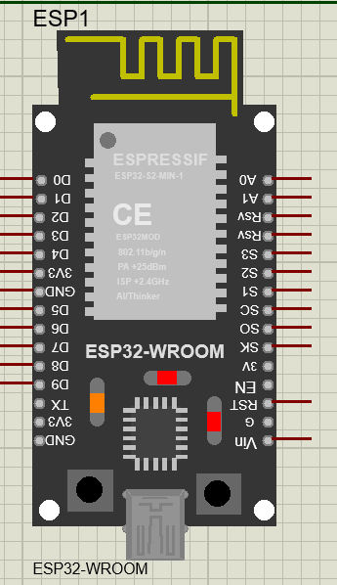
2. Compartmentalized Medication Storage and Sensing
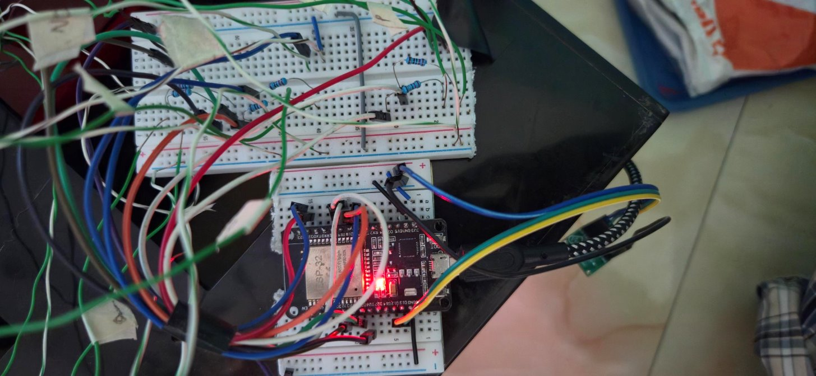
The physical medication storage is divided into three discrete temporal compartments: Morning, Lunch, and Night. Each compartment functions as an independent hardware subsystem equipped with its own local feedback loop, aimed at improving patient medication adherence [3]. State Indication (LED Matrix): Each compartment is equipped with a bi-color optical feedback system consisting of a Green LED (Standard 5mm, ~2.0V forward voltage) and a Red LED. To prevent current draw from exceeding the ESP32's maximum per-pin limit (40mA) and to ensure optimal brightness, each LED is placed in series with a 220Ω current-limiting resistor. The Green LED acts as an "Idle/Ready" indicator, while the Red LED serves as the active "Alarm" indicator. Interaction Detection: To monitor patient compliance, each compartment lid is equipped with a mechanical switch circuit. Rather than utilizing external pull-up or pull-down resistors, the hardware architecture leverages the ESP32's internal INPUT_PULLUP circuitry. The physical switches bridge the respective digital GPIO pins (D22, D23, D32) directly to a common ground. When a compartment lid is opened, the circuit completes, pulling the pin LOW. The edge firmware registers this state change as a confirmed pill consumption event.
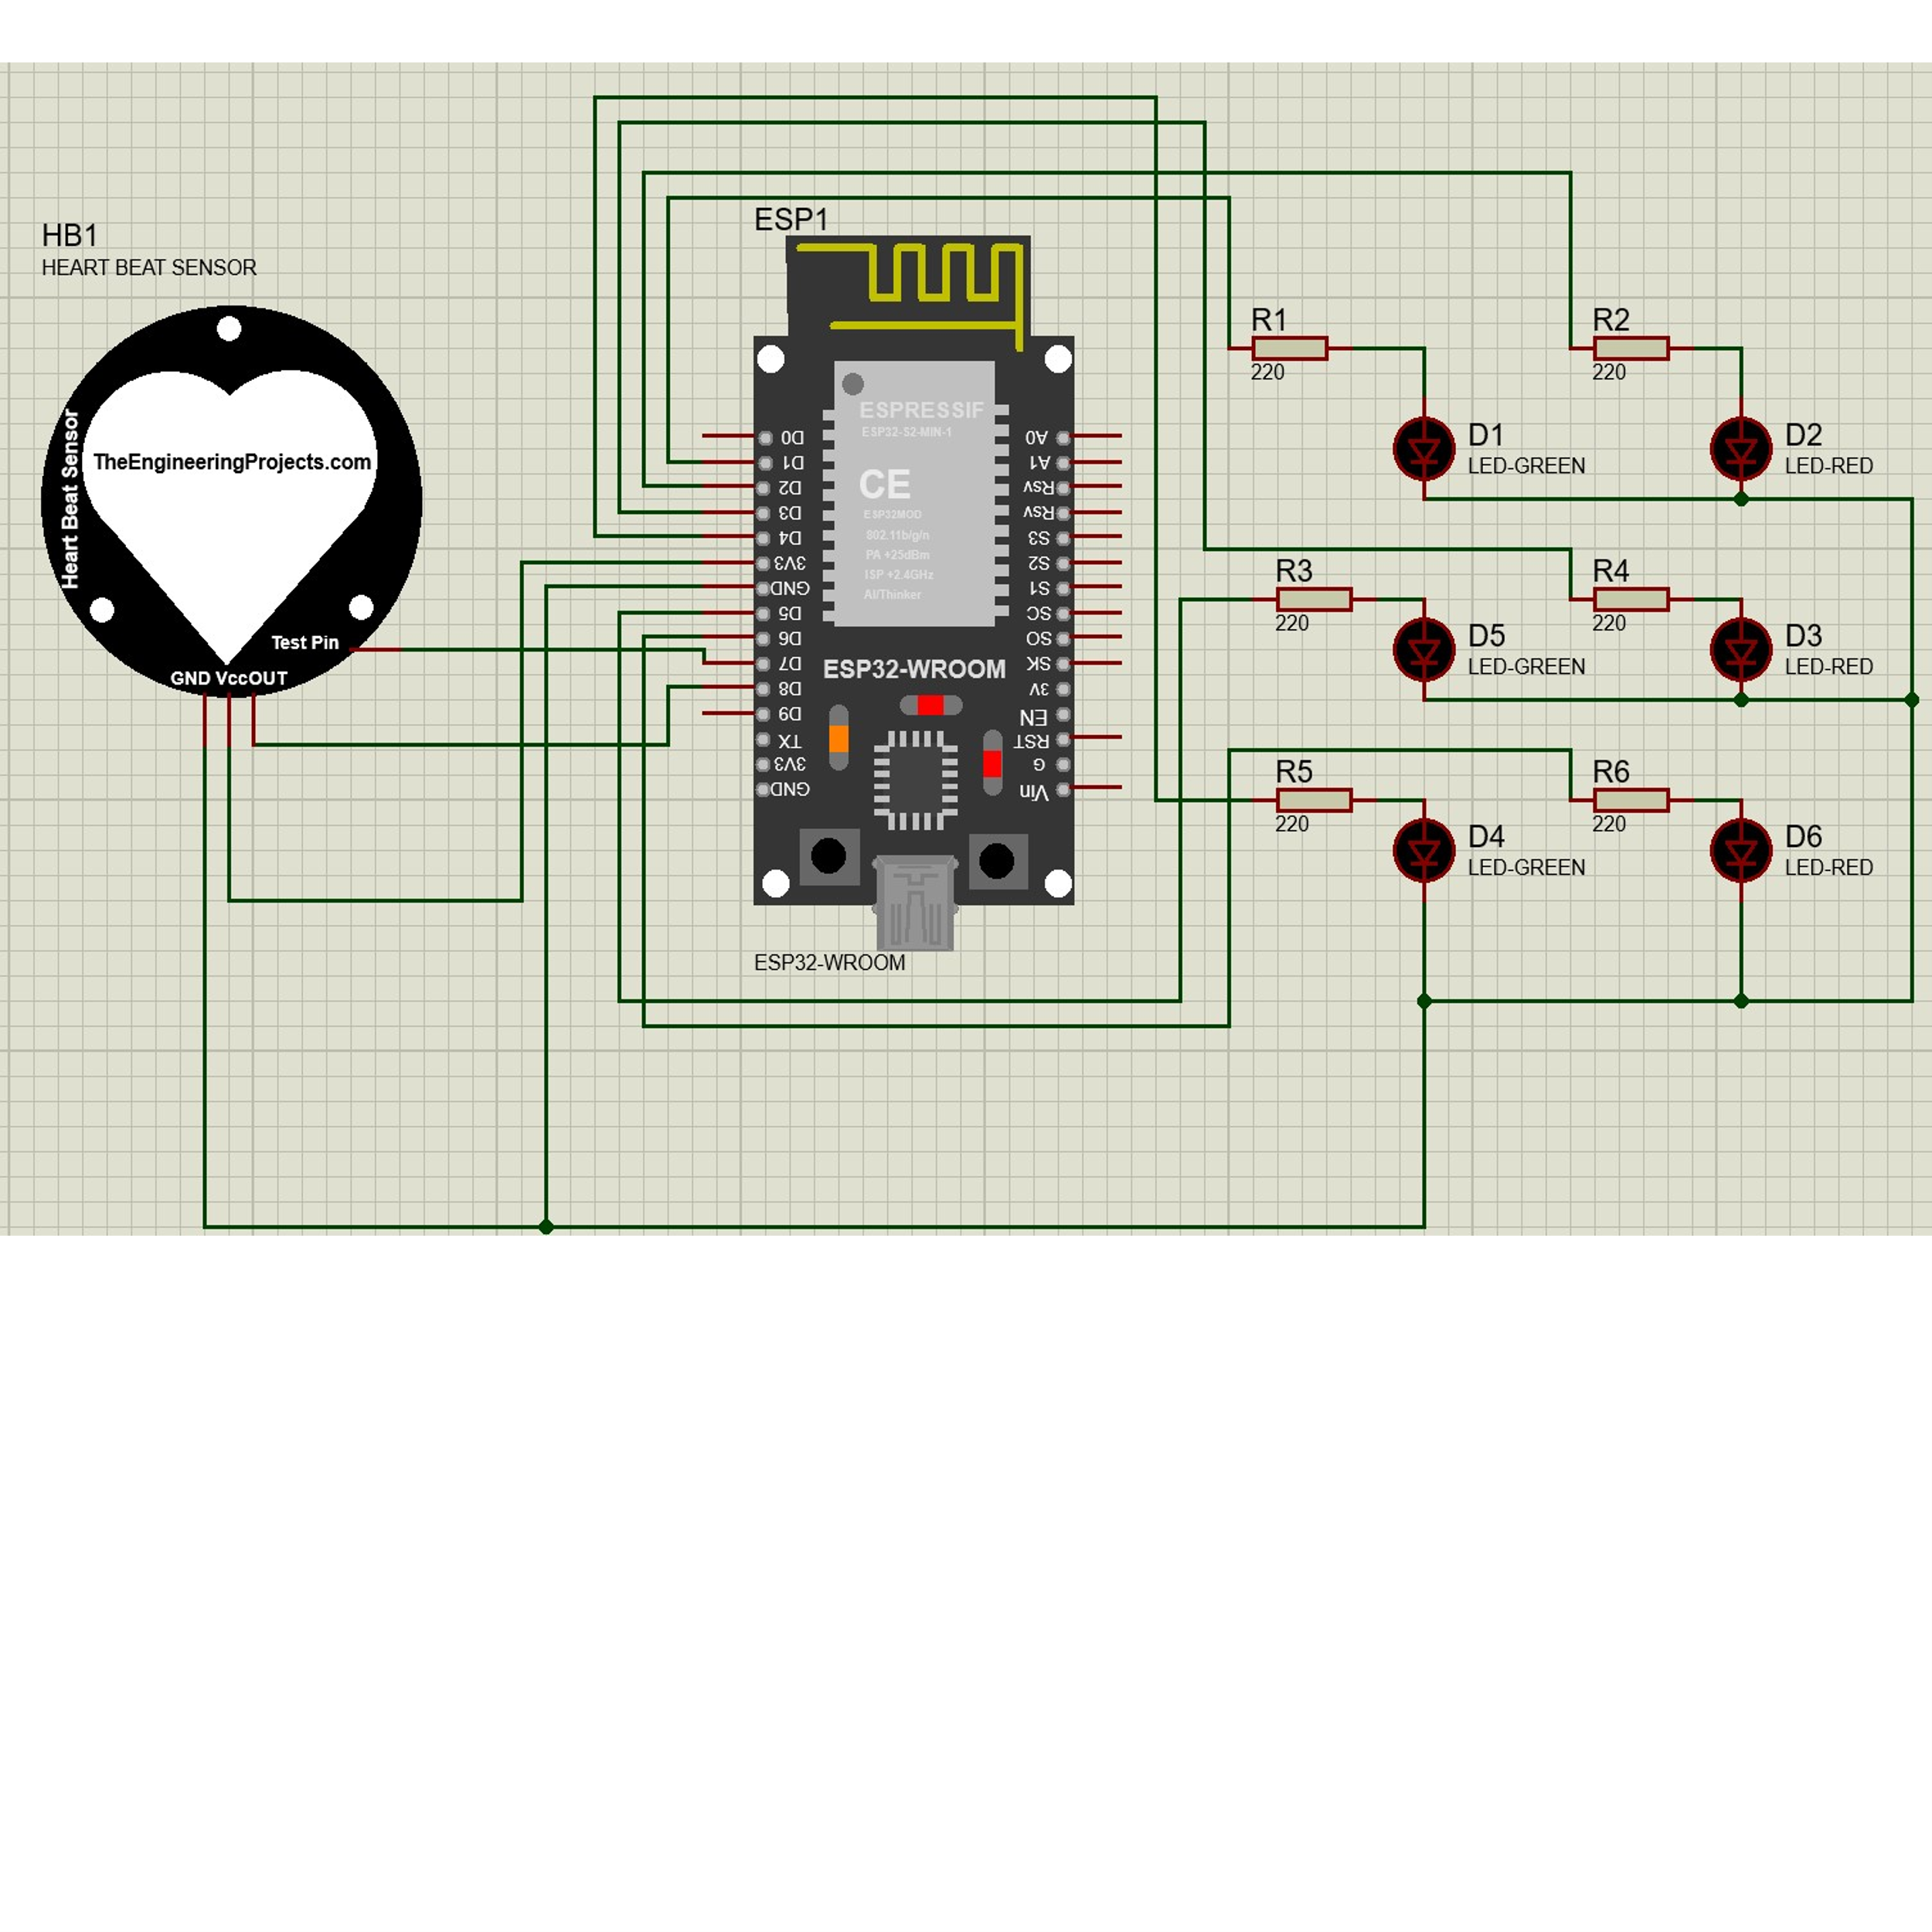

3. Optical Biometric Sensor Integration
To facilitate the localized tracking of patient vitals, the architecture incorporates a MAX30102 high-sensitivity pulse oximeter and heart rate sensor [4]. This module operates on the principle of reflective photoplethysmography (PPG). Optical Array: The module contains two specialized light-emitting diodes: a Red LED (660nm) and an Infrared (IR) LED (880nm). These wavelengths are optimized to measure the differential absorption of light by oxygenated and deoxygenated hemoglobin in the peripheral capillary bed. Data Acquisition: A built-in high-resolution Analog-to-Digital Converter (ADC) captures the reflected optical data. To ensure rapid data transfer to the primary processor, the sensor is interfaced with the ESP32 via an I2C bus running at a Fast Mode clock speed (400 kHz). The I2C lines are remapped to GPIO pins D12 (SDA) and D13 (SCL) to optimize the physical routing of the circuit board.
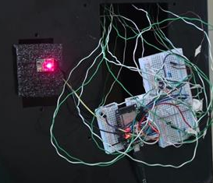
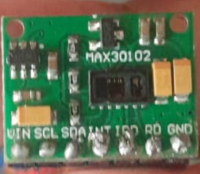

4. Power Distribution and System Constraints
The entire hardware suite is designed to be powered via a standard 5V USB interface. The power topology utilizes the ESP32 development board's onboard Low-Dropout (LDO) linear voltage regulator to step the 5V input down to the stable 3.3V required by the Xtensa microprocessor and the MAX30102 sensor logic. By actively monitoring the IR data buffer, the hardware employs an algorithmic power-saving mechanism. The ESP32 dynamically flushes the measurement arrays when the IR reflection drops below a critical threshold (indicating the absence of a finger), effectively forcing the sensor into a low-power "Idle State" when not actively gathering biometric samples.

References

[1] P. Fraga-Lamas, D. Barros, and S. I. Lopes, "The Role of ESP32 in Enabling Industry 4.0 and 5.0: A Comprehensive Narrative Review of Edge Intelligence, Human-Centric Automation, and Sustainable Innovation," IEEE Internet Things J., vol. 11, no. 11, pp. 19070–19093, 2024. [Online]. Available: https://www.preprints.org/manuscript/202508.0014
[2] A. Author et al., "Enhanced Secure Blockchain-edge-internet of Things System for Real-time Healthcare Monitoring," Int. J. Intell. Eng. Syst., 2025. [Online]. Available: https://inass.org/wp-content/uploads/2025/08/2025113032.pdf
[3] R. Al-Shammary, D. Mousa, and S. E. Esmaeili, "The design of a smart medicine box," in Proc. Iranian Conf. Electr. Eng. (ICEE), May 2018, pp. 130–134, doi: 10.1109/ICEE.2018.8472476.
[4] S. Author et al., "An IoT-Based Wireless Wearable Health Monitoring System Using ESP32 with Machine Learning-Driven Cloud Visualization," Int. J. Drug Deliv. Technol., vol. 16, 2025. [Online]. Available: https://impactfactor.org/PDF/IJDDT/16/IJDDT,Vol16,Issue37s,Article17.pdf

